fdi in the region of valencia in 2021

In 2021, investments in the Valencian Community recovered strongly. This recovery, which was already apparent in the increasing number of potential investors that the Valencian Investment Desk has had to deal with since mid-2020, has been reflected in the data recently published by the Foreign Investment Registry.
Thus, after 2020 in which productive investment flows in the Region of Valencia were severely affected by the Covid-19 pandemic, with a 54% drop in investment flows received compared to 2019, in 2021 856 million euros were invested in the region. This figure is 142% higher than the previous year and is once again above the annual average for the region (619 million annually since the beginning of the century).
With 3% of the flows, the Region of Valencia is the fifth region that received the most investment in 2021, after Madrid -73% of the total-, Catalonia, the Basque Country and Andalusia. However, the growth registered in the Region of Valencia is, by far, the highest of the five, and much higher than the growth for Spain as a whole.
As at the national level, crossborder M&A operations played a major role in 2021 in the region of Valencia. These types of operations accounted for 569 million, 66.5% of the total, above the average in the last decade (45.6%).
Particularly noteworthy in this strong recovery are the investments received from Italy (392 million, mainly in Maritime freight transport, Manufacture of refractory ceramic products and the Food Industry), France (151 million, mainly in Manufacture of bodies (coachwork) and Wholesale trade) and the United States (91.6 million, especially in Research and Development, Furniture Manufacturing and Specialist medical practice activities). In 2021, investments from other European countries accounted for 85% of the investment, almost all of it from EU14 countries. North America accumulated 11% of investment in the year, while Asia barely reached 3.4%.
Private sources such as fDi Markets (Financial Times) show a similar trend: after a 2020 in which both the number of projects and the associated investment fell significantly, the recovery in 2021 was strong in the Region of Valencia. 56 investment projects were announced in the region (+33% compared to 2020), the second best record in the historical series, with an associated investment of $1,18 billion and the generation of 4,168 local jobs.
As has happened in the rest of Spain, employment levels linked to foreign investment in the Valencian Community have recovered notably in recent years, already exceeding pre-crisis levels. The Region of Valencia has experienced seven years of growth, since the minimum registered in 2012, reaching 112,132 jobs in the region according to recently published data corresponding to 2019.
The foreign investment position also registered an increase in the last update, corresponding to 2019, to 6,727 million euros (+6.7%), 5.8% of regional GDP in the year.
The outlook for 2022 is uncertain. At the beginning of the year, rebounds as intense as the one experienced in 2021 were not expected, but Russia’s invasion of Ukraine adds more uncertainty to an already complicated scenario, in which the evolution of the pandemic, high energy prices, rising inflation and the bottlenecks in supply chains were already cited as key factors to look out for.
On the other hand, the interest received by IVACE Internacional from potential investors, the recent evolution of greenfield projects or the strong investments announced in recent months in the region, which should materialize and be recorded in the registry throughout the year, make for a somewhat more optimistic local view.
Evolution of gross productive FDI in the Region of Valencia
Millions of €, No-ETVE

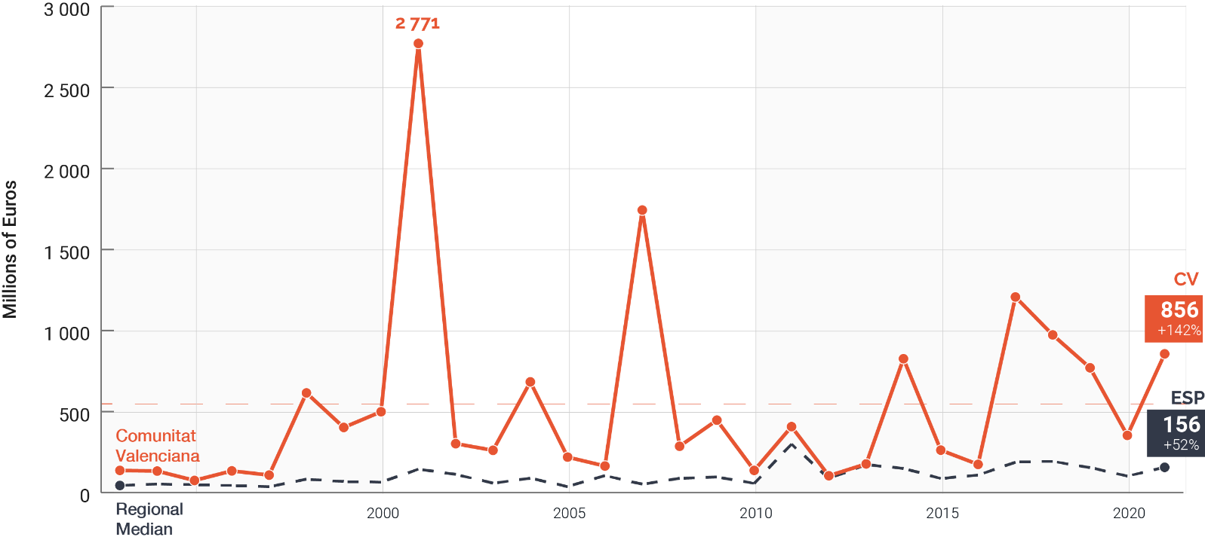
Source: Investment Registry, March 2022

